Are you a confident driver?
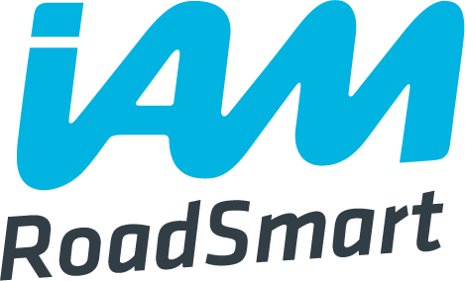
The WI and IAM RoadSmart join forces to develop women’s driving skills

IAM RoadSmart (formerly known as the Institute of Advanced Motorists) is the UK’s leading independent road safety charity who passionately believes that our roads can be made a safer place by improving the standards of the people who are using them. With over 50 years of experience, passion and insight, the IAM is uniquely positioned to help improve the skills and understanding of UK drivers, riders and cyclists.
Following two hugely successful driving days, held in 2016, this year will see member’s being offered another two exciting opportunities to develop their driving skills and confidence on the roads at exciting, and bespoke, one-day events…

Saturday 16 September 2017  The British Motor Museum, Gaydon  Warwickshire  10am – 4pm  Cost to attend: £55 each | Saturday 23 September 2017  Hayes International Motor Museum, Yeovil  Somerset  10am – 4pm  Cost to attend: £55 each

Hosted by IAM professionals, the day will consist of a variety of workshops and driving sessions* covering a range of topics such as:
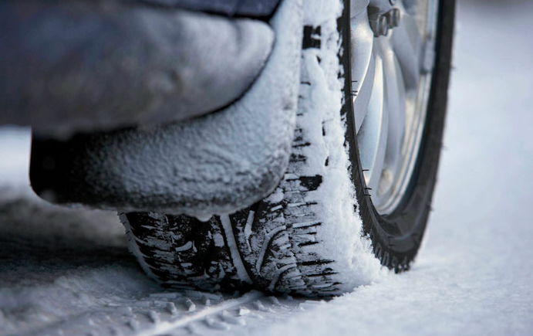
- Driving in bad weather conditions
- How to drive safely with passengers
- One-to-one driving assessment
- Speed awareness
- One-to-one parking and manoeuvring techniques
- Personalised guidance and support from an IAM professional

A hot lunch and refreshments is included in the ticket price.

Spaces are limited and we are expecting these events to sell out quickly. Please complete and return your application form, along with your payment (cheques must be made payable to NFWI) as soon as possible to Helen Neal at the NFWI Unit, Denman, Marcham, Abingdon, Oxon, OX13 6NW. Please contact 01865 391788 ext 279 or h.neal@nfwi-unit.org.uk with any questions.

* Members must ensure they have a full driving license and insurance and will be required to sign a declaration form to confirm that they have the adequate insurance. Members are not required to take a specific insurance for this day; full comprehensive will suffice.


Please note: ticket price is non-refundable unless the event is cancelled by the NFWI, IAM RoadSmart or the hosting venue.

